

**Graphics Processing**

**Project Documentation**

Tudor-Mihai Iakkel

Group 30432

Assistant Teacher: Diana Cristina Enoiu

**Table of Contents**

1. **Subject Specification**
2. **Scenario**

2.1. Scene and objects description

2.2. Functionalities

1. **Implementation Details**

3.1. Functions and special algorithms

3.1.1. Possible solutions

3.1.2. The motivation for the chosen approach

3.2. Graphics Model

3.3. Data Structures

3.4. Class hierarchy

1. **Graphical User Interface Presentation / User Manual**
2. **Conclusions and further developments**
3. **References**
4. **Subject Specification**

The subject of this project is presenting a photorealistic scene, including 3D objects and different effects, using the OpenGL library. OpenGL (Open Graphics Library) is a cross-language, cross-platform application programming interface (API) for rendering 2D and 3D vector graphics. The API is used to interact with the graphics processing unit (GPU) to achieve hardware-accelerated rendering.

The scene I chose to implement is a war-torn battlefield where, besides the presence of a multitude of destroyed/damaged tanks, houses and trees, there also is a “healthy” tank, which the user is able to interact with and move around the place.

1. **Scenario**

**2.1. Scene and object description**

The scene represents a post-fight battlefield in the middle of a small forest. The 3D objects that can be seen upon running the application are the following:

* 3 types of trees
* dead tree trunks
* houses
* 2 “functional” tanks
* 4 types of damaged/destroyed tanks
* a lamppost
* bushes

Also, the chosen skybox depicts a lot of clouds all around the scene. Lastly, the objects are sat on a grassy-like surface, suitable for the small forest they are situated in.

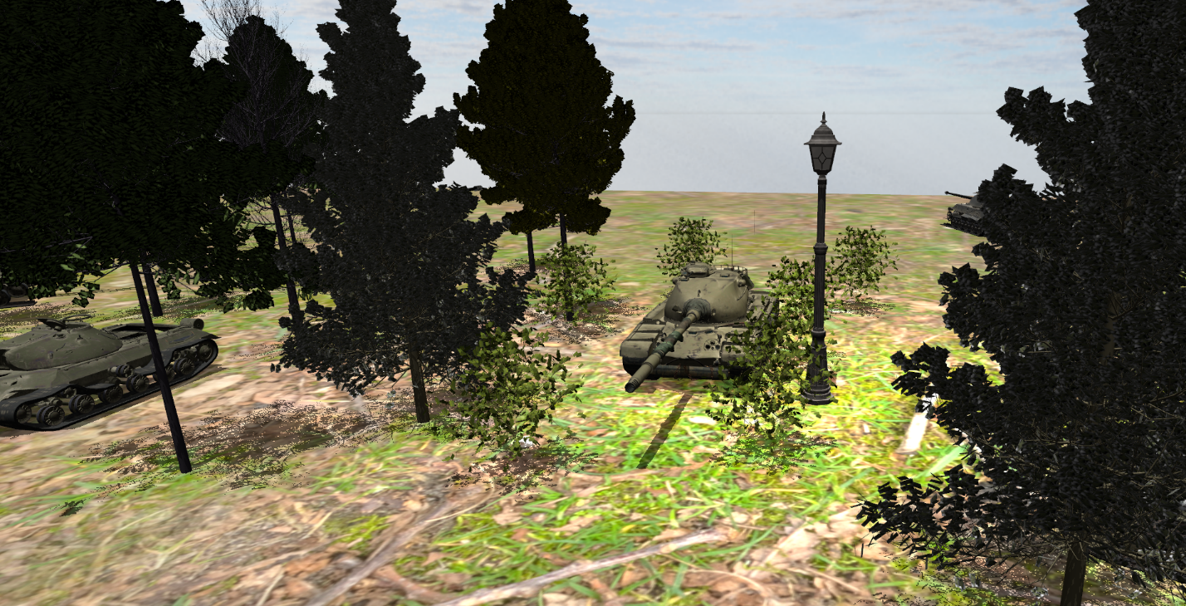

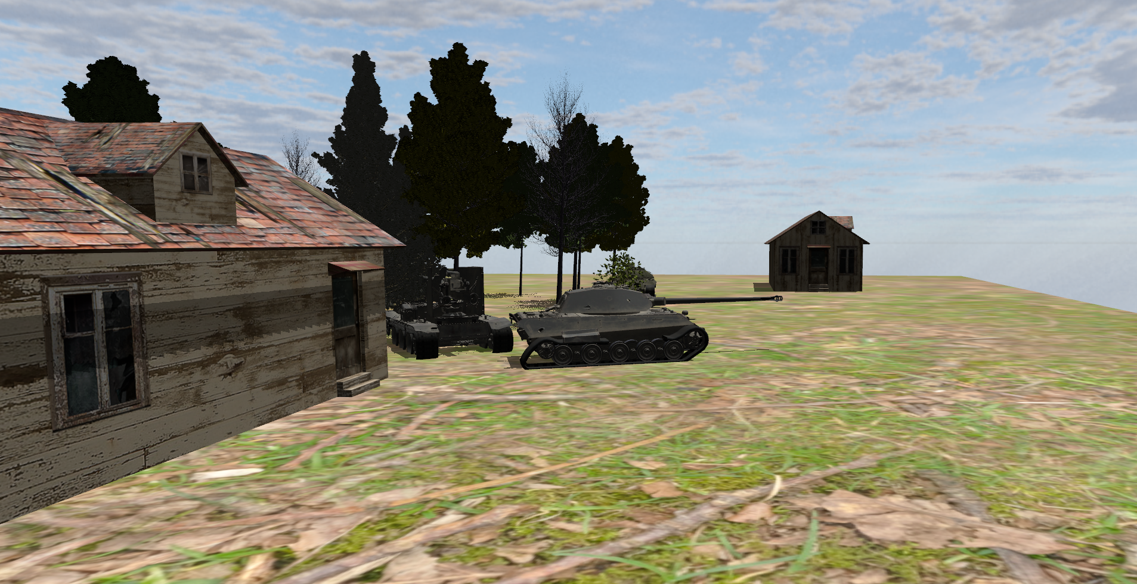

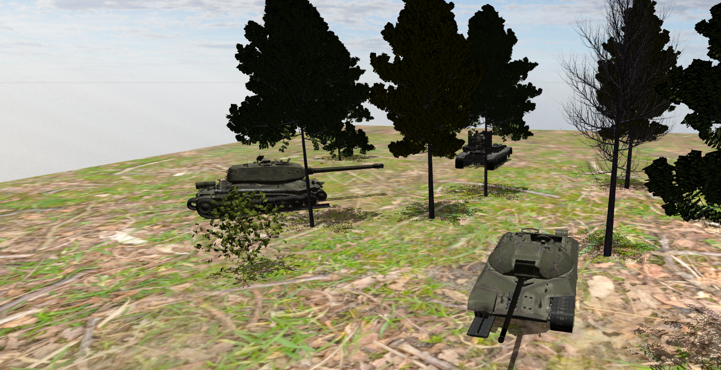

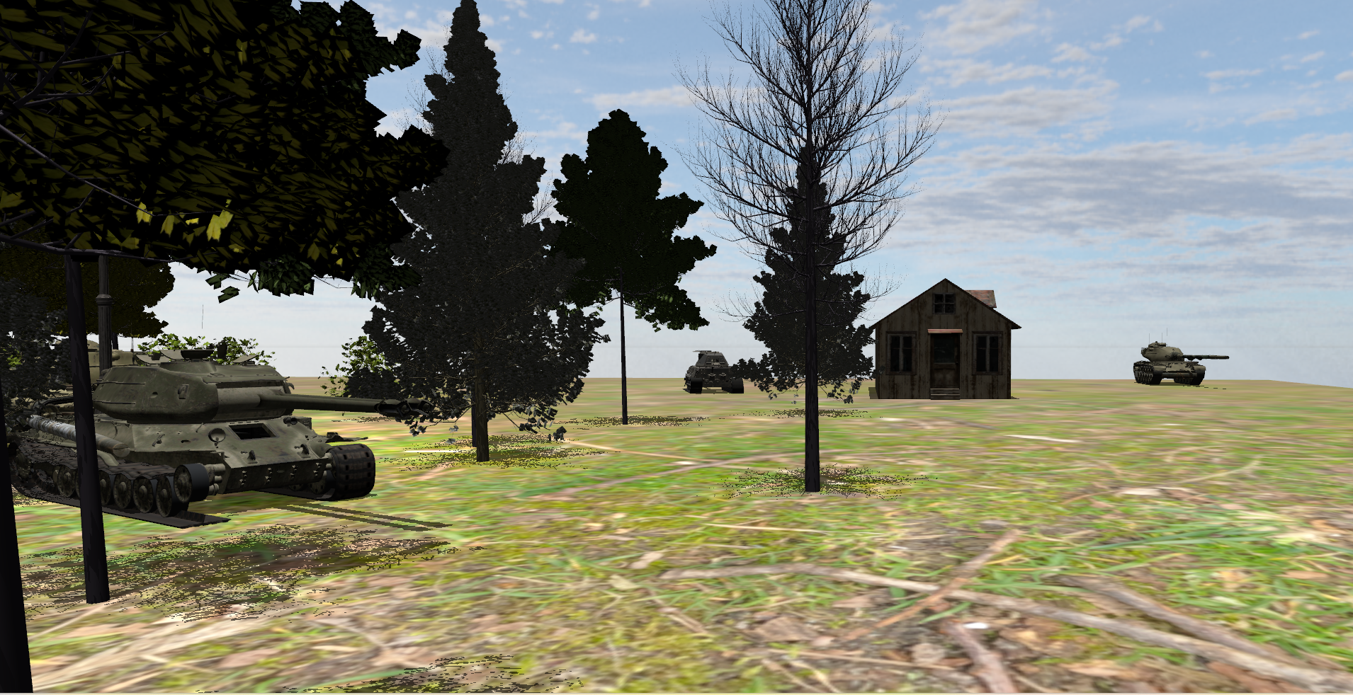

**2.2. Functionalities**

Upon running the application, the user can move around the scene using the keyboard and mouse. It can also switch between the solid view and wireframe viewing modes of the objects. The user can choose to look at a foggy scene with the press of a button, as well as changing the density of the fog. The tank in the middle of the scene can be maneuvered around the battlefield using the keyboard.

There are 2 different light sources in the project: a directional light, which is sat very high in the “sky” and illuminates the entire scene, and a spotlight, which can be seen right where the lamppost is situated, very close to the tank in the middle.

Lastly, there is another “functional” tank sat in one of the corners of the scene which is fully turning its turret by itself.

All of the relevant keys for manipulating the previously defined functionalities are presented in Chapter 4. User Manual.

1. **Implementation Details**

**3.1. Functions and special algorithms**

**3.1.1. Possible solutions**

The functions used throughout the project are mostly present in the OpenGL library, with a few additional functions implemented by me. Some these functions are:

* **glViewport(…)** – used for setting Viewport transform
* **glGenTexture(…)** – generates the textures for an object
* **glBindTextures(…) –** binds the textures onto an object
* **glfwCreateWindow(…**) – creates the viewing window of the application
* **glTextImage2D(…) –** creates the depth texture for the Framebuffer objects
* **glUniformMatrix4fv(…**) – sets the values of a 4x4 matrix uniform variable in the shader
* **glUniformMatrix3fv(…) –** same function, but relevant for 3x3 matrices.
* **others.**.

Some fundamental functions used in this application present in the main class are the following:

* **renderScene(…) –** renders the objects, textures, shaders and everything else relevant to the scene; continuously called until the window is closed
* **initShaders() –** initializes all the shaders used throughout
* **initObjects() –** loads every 2D or 3D object that will be used in the scene
* **initUniforms() –** instantiates all the uniform variables that will be used later on in the fragment and vertex shader files
* **initFBO() –** initializes all the Framebuffer Objects
* **drawObjects() –** places all the objects previously defined at specific coordinates in the rendered scene
* **keyboardCallback(…**) - computes the desired changes for pressing a certain key on the keyboard
* **mouseCallback(…) –** allows the user to use the mouse for turning the viewing camera
* **processMovement() -** allows the user to move the viewing camera or other objects around the scene upon pressing certain keys
* **others.**.

Other important functions, present in other classes:

* **Camera::move(…) –** moves the viewing camera around the scene based on the direction inputs from the keyboard
* **Camera::rotate(…) –** rotates the viewing camera based on the mouse inputs
* **Model3D::update() –** computes and returns the delta time between the current time and the last frame; really helpful for designing animations

As for the lighting and shadows computations, they were done in the shader files of the project. The implemented algorithms are the ones defined and described during the laboratories this semester.

**3.1.2. The motivation for the chosen approach**

During the semester, the laboratory works were situated around the previously defined implementations, ranging from simple assignments such as translating and rotating objects, to more difficult ones like computing shadows or different light sources. I chose to follow this path because having this starting point and a backbone of the project was really helpful and easy to understand, and further additions were also much easier to implement.

**3.2. Graphics Model**

Most of the objects’ models and textures have been downloaded from different websites from the Internet (available in Chapter 6. References). Though, in the case of the tank objects and textures used in the project, they were taken from the “World of Tanks” game files with the help of a third-party app, which would extract the tanks from the files and let me export them as FBX files.

All of the objects were then imported into Blender for further adjusting, rescaling, etc. The main tank present in the scene was the object who suffered the most changes: I used the object from the game files and then added 2 more components on it which were present on other tanks from the game: a transparent camo net (situated on the gun barrel) and a “rammer” (situated at the very front of the hull).

After the Blender stage, the objects were exported into the project’s files as OBJ format, which would also come with an MTL file, responsible for adding the textures onto the objects.

**3.3. Data Structures**

As for the data structures, this chapter is underwhelming because there was no use for complex structures. The attributes of the different types of lighting, shadow, fog and everything else were held together by simple data structures. Some of them have already been implemented in the laboratories, so it was pretty useful to have them in my project as well.

**3.4. Class hierarchy**

The classes present in the project are the following:

* **Camera** – contains the implementation of the viewing camera and its movement
* **Model3D** – contains the implementation of the 3D objects available in the application
* **Shader** - contains the implementation of the shaders
* **SkyBox** - contains the implementation of the skybox
* **Mesh** – represents a 3D object; includes data structures like Vertex, Texture, Shader

1. **User Manual**

The user can manipulate the scene using the following keys:

* W – Camera moves forward
* S – Camera moves backwards
* A – Camera moves to the left
* D – Camera moves to the right
* Up Arrow – Tank moves forward
* Down Arrow – Tank moves backwards
* Left Arrow – Tank moves to the left
* Right Arrow – Tank moves to the right
* 1 – Fog appears/disappears
* 2 – Fog intensity increases
* 3 – Fog intensity decreases
* 4 – Viewing mode changes between solid and wireframe
* Esc – The app closes

1. **Conclusions and further developments**

In conclusion, working on this project proved to be quite a ride for both good and bad reasons. At first, the project seemed overwhelming as there was a lot of code to dig into and understand, but once I got the hang of everything, it was smooth sailing from then on.

Also, working in Blender proved to be quite entertaining, even though I only changed the structure of a few objects. Getting to know some of the intricacies of this software will most definitely be useful in the future.

Overall, this was a fun project to work on, where I learned many different new technologies and implementation techniques, ranging from easy and really useful ones like working Blender, to more obscure ones like working with MTL files.

As for further developments on this project, we can have:

* Shadow from the spotlight present in the lamppost
* Smoke particles coming out from destroyed tanks, houses or trees
* Rain
* Night mode, with a different skybox and a moon-like light source
* Adding other types of objects relevant to the scene
* Adding terrain
* Others..

1. **References**

* Poly Haven - https://polyhaven.com/
* TurboSquid - <https://www.turbosquid.com/>
* Free3D - <https://free3d.com/>
* Youtube
* CGTrader - <https://www.cgtrader.com/>
* Learn OpenGL - https://learnopengl.com/